3 May, 2016

Dr. Lina Guo
School of Electronics and Information,
GuangDong Polytechnic Normal University
Guangzhou 510665
China

Phone: 86 13710569480
Email: guoln523@qq.com

Passport No.: PE0882989
Citizenship: China
Gender: Female
Date of Birth: 05/23/1981

Dear Dr. Lina Guo:
Thank you for your interest in attending the OSA Meeting: Frontiers in Optics: The 100th OSA Annual Meeting and Exhibit/Laser Science XXXII (FiO 2016). The meeting will be held at the Rochester Riverside Convention Center October 17-21, 2016 in Rochester, New York, USA. The meeting is open to all OSA members and those with related optics.
This letter serves as a formal invitation for you to participate in the meeting. Your participation in the meeting includes presenting your paper, attending sessions in your area of interest, and an opportunity to communicate with others working in the field of optical science.
This is an invitation to participate in the meeting, but not a personal sponsorship of your stay in the United States. You will need to secure your own funding for travel, registration, and housing expenses for the meeting. Additional meeting information, including visa requirements, is available on the OSA website at www.osa.org.
Sincerely,
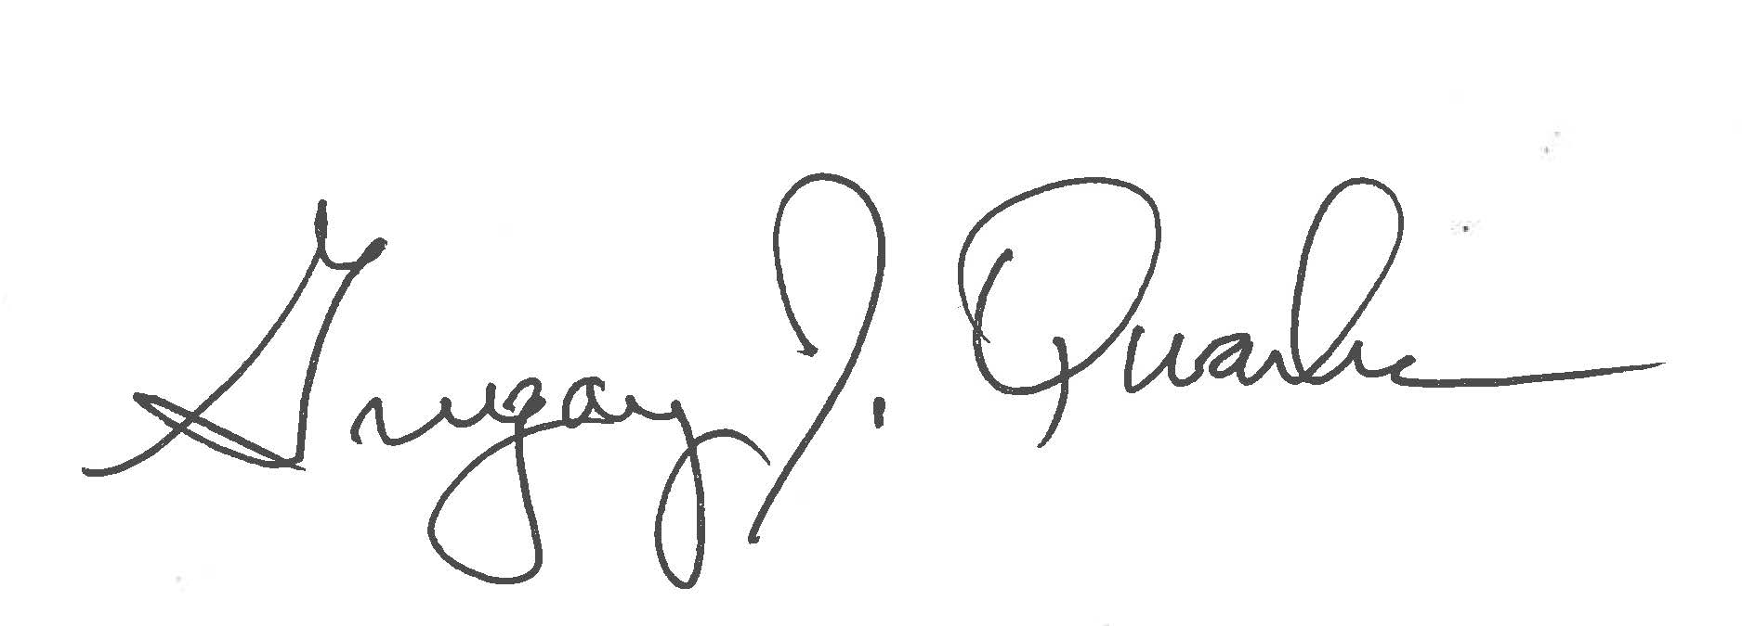
Gregory Quarles, PhD
Chief Scientist, Executive Programs

